Hi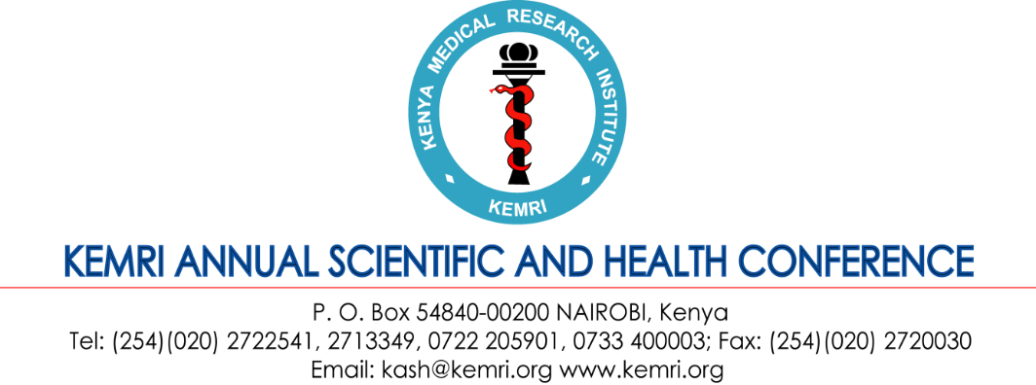

KEMRI Annual Scientific and Health Conference
15th – 17th February 2023

Theme: Rethinking strategic research-for-health through partnerships, innovation, evidence generation, and knowledge sharing in post-pandemic recovery era

SYMPOSIUM DETAILS
About the KASH Conference
The Kenya Medical Research Institute (KEMRI) will be hosting its 13th KEMRI Annual Research and Health (KASH) Conference from 15th to 17th February 2023. The conference will, among other things, showcase the research activities that are going-on in the areas of our mandates as well as serve as a forum for dissemination, networking, and highlight ongoing and planned activities at country level. The conference attracts an estimated 450 participants within Kenya and beyond.

Benefits of hosting a symposium during the 13th KASH Conference 2023
Symposium sessions run parallel to breakaway conference session and usually take place in the afternoon period. The half day sessions are usually allocated a maximum of 3 hours. The KASH Symposium Package consist of a dedicated hall that can host up to 100 pax full loaded with audio vision equipment. Ushers will be available to direct conference participants to the respective halls as well as assist in site delegate registration. During the plenary sessions, continuity symposium announcement will be displayed on the various electronic screens for the audience to take note of. In addition, the KASH Organizing Committee will require a synopsis of the symposium for inclusion into the book of abstracts. Kindly do provide this details by 15th December 2022 so as to allow the graphics team to insert the same into the official book of abstracts.

The cost of hosting a symposium is Kenya Shillings 100,000/= (One hundred thousand Kenya shillings only). For KEMRI related projects, the team leaders would be required to issue authorization of funds deduction letter to Director, KEMRI. For non-KEMRI Projects, make payments to KCB account number (A/C): 1112776850. Or use MPESA Pay Bill number 522522, account 1112776850.

SYMPOSIUM APPLICATION FORM
Name of Organizer/Chair:

Name of Co-chair:

Rapporteur:

Institution / Organization /Project:

BRIEF SUMMARY OF SYMPOSIUM DESCRIPTION

Title of the symposium:
Summary (Up to 300 words maximum):
Names of presenters and titles of presentations
An estimate of the number of people likely to attend your symposium.
For KEMRI Project, state the Project Account Name and Number (note: kindly attach a funds deduction authorization letter separately to the application)

TERMS & CONDITIONS
By returning this signed Symposium Sponsorship Agreement (“Agreement”), you agree to undertake hosting a parallel scientific session (“Symposium”) during the 13th KEMRI Annual Scientific & Health Conference (KASH) on the following terms and conditions set out below and as attached to this Agreement.
- Confirmation of hosting a symposium and related entitlements will NOT commence until the 75% cash deposit has been paid. Deposit is due by 1st December 2022. Full payment will be required by 31st January 2023.
- Monies paid are non-refundable.
- Please note that your requested category of symposium may have a limit to the number of participants likely to attend your symposium and by extension the KASH conference, and preference in session room allocation and related requirements will be determined in order of receipt of the signed Agreement and cash deposit. The conference secretariat will notify you if we are unable to get additional rooms, audio-visual equipment etc.
- At the end of the session, you will be required to submit to the KASH Secretariat, a summary of the proceedings. These materials shall be deemed to be property of and a copy right of the KASH Conference.
- The KASH Publicity Committee must approve the size and content of all inserts in the conference delegate packs.
- Nothing contained in this Agreement will be deemed to constitute a partnership, joint venture or agency relationship between you and the KASH Secretariat.
Symposium Sponsor’s Signature:
Date:

Thank you for supporting the 13th KEMRI Annual Scientific & Health Conference.

Submit a signed PDF application form to kash@kemri.org

