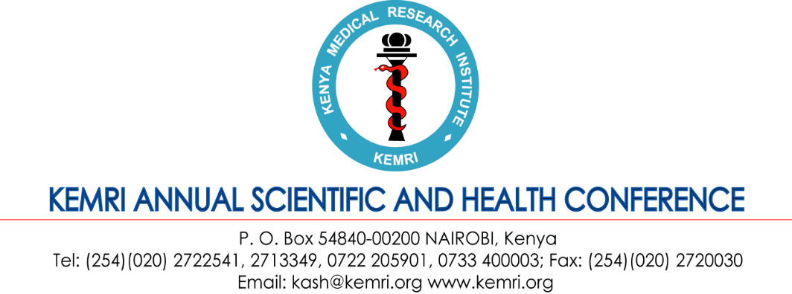

KEMRI Annual Scientific and Health Conference
9th – 12th February 2027

Theme: Translating Research Evidence to Impact: Scaling Health Innovations for Economic
Growth

SYMPOSIUM DETAILS
About the KASH Conference
The Kenya Medical Research Institute (KEMRI) will be hosting its 17th KEMRI Annual Research and Health (KASH) Conference from 9th to 12th February 2027. The conference will, among other things, showcase the research activities that are going-on in the areas of our mandates as well as serve as a forum for dissemination, networking, and highlight ongoing and planned activities at country level. The conference attracts an estimated 1,000 participants within Kenya and beyond.

Benefits of hosting a symposium during the 17th KASH Conference 2027
Symposium sessions run parallel to breakaway conference session and usually take place in the afternoon period. The half day sessions are usually allocated a maximum of 3 hours. The KASH Symposium Package consist of a dedicated hall that can host up to 100 pax full loaded with audio vision equipment. Ushers will be available to direct conference participants to the respective halls as well as assist in site delegate registration. During the plenary sessions, continuity symposium announcement will be displayed on the various electronic screens for the audience to take note of. In addition, the KASH Organizing Committee will require a synopsis of the symposium for inclusion into the book of abstracts. Kindly do provide these details by 15th December 2026 so as to allow the graphics team to insert the same into the official book of abstracts.

The cost of hosting a symposium is Kenya Shillings 150,000/= (One hundred and fifty thousand Kenya shillings only). For KEMRI related projects, the team leaders would be required to issue authorization of funds deduction letter to Director, KEMRI. For non-KEMRI Projects, make payments to KCB account number (A/C): 1112776850. Or use MPESA Pay Bill number 522522, account 1112776850.

Attendees will also be required to pay the registration fee as per the call

SYMPOSIUM APPLICATION FORM
Name of Organizer/Chair:
Name of Co-chair:
Rapporteur:
Institution / Organization /Project:
BRIEF SUMMARY OF SYMPOSIUM DESCRIPTION
Title of the symposium:
Summary (Up to 300 words maximum):
Names of presenters and titles of presentations
An estimate of the number of people likely to attend your symposium.
For KEMRI Project, state the Project Account Name and Number (note: kindly attach a funds deduction authorization letter separately to the application)
TERMS & CONDITIONS
By returning this signed Symposium Sponsorship Agreement (“Agreement”), you agree to undertake hosting a parallel scientific session (“Symposium”) during the 17th KEMRI Annual Scientific & Health Conference (KASH) on the following terms and conditions set out below and as attached to this Agreement.
- Confirmation of hosting a symposium and related entitlements will NOT commence until the 75% cash deposit has been paid. Deposit is due by 1st December 2026. Full payment will be required by 31st January 2027.
- Monies paid are non-refundable.
- Please note that your requested category of symposium may have a limit to the number of participants likely to attend your symposium and by extension the KASH conference, and preference in session room allocation and related requirements will be determined in order of receipt of the signed Agreement and cash deposit. The conference secretariat will notify you if we are unable to get additional rooms, audio-visual equipment etc.
- At the end of the session, you will be required to submit to the KASH Secretariat, a summary of the proceedings. These materials shall be deemed to be property of and a copy right of the KASH Conference.
- The KASH Publicity Committee must approve the size and content of all inserts in the conference delegate packs.
- Nothing contained in this Agreement will be deemed to constitute a partnership, joint venture or agency relationship between you and the KASH Secretariat.

Symposium Sponsor’s Signature:
Date:

Thank you for supporting the 17th KEMRI Annual Scientific & Health Conference.
Submit a signed PDF application form to kash@kemri.go.ke

